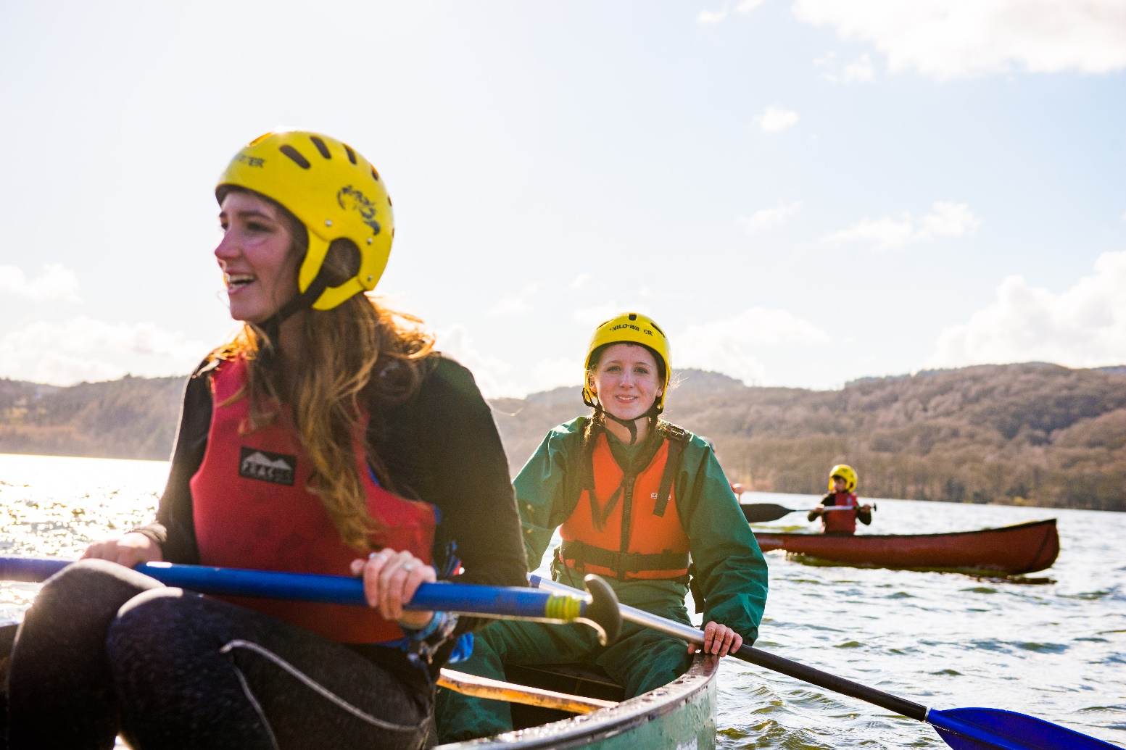
Deputy Distrct Youth Commissioner

Information for anyone considering the role of Deputy District Youth Commissioner at Biggleswade District Scouts

About us
Overview of Youth Shaped
At Scouts, we provide young people with the opportunities to develop Skills for Life – including confidence to speak up, feeling empowered to make a difference and being ready to take the lead.

That’s what being youth shaped is all about. Our programmes and decisions are shaped by young people, working in partnership with volunteers.

The difference you’ll make to young people
Youth commissioners help young people to make their voices heard and improve scouts for the better. You’ll be working to help more young people get the opportunity to speak up and take the lead – skills and experiences that set them up for the future. And in the process, you’ll get to learn plenty of new skills yourself too.

The current vacancy
We’re currently looking for 2 or 3 Deputy District Youth Commissioners to work with the District Youth Commissioner at Biggleswade District scouts.
What does a youth commissioner do?
Youth Commissioners and Deputy Youth Commissioners are volunteers responsible for driving youth shaped in their local area. They support volunteers, shape the programme, influence decisions that we make at Scouts and take the lead.

They are aged 18-25 at appointment and enable volunteers to embed the ideas and decisions of young people into local scouting.

They play a key role in the leadership and management of the District. They need to motivate both volunteers and young people. Responsibilities in a deputy youth commissioner role vary, but are likely to include working with the youth commissioner and other deputy youth commissioners to:

- Support volunteers to put the views and ideas of young people at the heart of their section’s programme
- Promote participation in the YouShape award in their District, as well as top awards
- Help to ensure that young people get regular opportunities to take the lead, including promoting participation in the young leader’s scheme
- Inspire and motivate young people in the District, ensuring they know about all the different opportunities available to them in scouting, including when they reach 18 years old

Support every step of the way
Deputy District Youth Commissioners are line managed by the District Commissioner, who will help you set objectives for the District Youth Commissioner and Deputy Youth Commissioners and work with you towards improving local youth shaped scouting.

Each County also has a County Youth Commissioner who will be able provide support.

And the UK Youth Commissioner team are also here to support Youth Commissioners too - running inductions, events, webinars and more. So you’ll have support available whenever you need it.

What you’ll get from the role
Being a Youth Commissioner is an amazing role. As well as helping to drive youth shaped locally and giving young people a say, you’ll also be learning loads of new skills and having fun along the way.
You’ll get experience and develop skills that will look seriously impressive on a CV or university application - things like teamwork, communication and organisation, but also experience with governance, working with young people and leading others.
Across the UK, there are now over 600 Youth Commissioners doing amazing things. Ready to join them?

“Applying to become Youth Commissioner was genuinely one of the best decisions I’ve ever made. Through this role I’ve learned so much, got to work with a really great team, and made a big difference to the experience of young people in Scouts”.

“I never thought I’d get the role, but I decided to apply anyway just in case. 3 years later, I’m so glad I did. I’d recommend applying to everyone who is considering it”.

“What surpised me most when starting the role was the amazing support that was available from my local team and other youth commissioners. I’ve made new friends and gotten to work with some great people”.

“Seeing the difference this role makes to young people is the best part. I’ve watched young people speak up and shape their scouting experience for the better – and I couldn’t be more proud”.

How the process works
Process
Thank you for your interest in volunteering.
You can apply for the role yourself using the application form or nominate someone else using the nomination form. Nominated people are under no commitment to apply unless they wish to.
Shortlisting will be based solely on the information provided by each candidate in their application form. All applications should address the requirements of the role, as laid out in the role description and person specification

Key dates
The closing date for applications is 31st December 2021
Interviews will be held during January and February 2022.

Further information
For more information, or for an informal chat about this vacancy, please contact:
Name: Rob Pullinger (District Commissioner)
Email: Rob.Pullinger@biggleswadedistrictscouts.org.uk

All about the role – Deputy District Youth Commissioner

Outline role description
Outline:
As a member of the District Leadership Team the Deputy District Youth Commissioner works in partnership with the District Youth Commissioner, othe Deputy District Youth Commissioners, the District Commissioner and Chairperson of the District Executive Committee. The role is to ensure that young people from 6 – 25 years are involved and engaged in every decision that shapes their Scouting experience locally and to empower young people to share their ideas and have a meaningful voice in planning, implementing and reviewing their programme and opportunities.
Responsible to:
District Youth Commissioner
Responsible for:
None
Main Contacts:
Young people within their District, District Youth Commissioner, Deputy District Youth Commissioners, District Commissioner, District Youth Forum Lead, Deputy District Youth Commissioners, Deputy District Commissioners, County Youth Commissioner, Assistant District Commissioners, District Chairperson, members of the District Executive Committee and its sub-committees and other local District Youth Commissioners.
Appointment requirements:
18-25 years old at the time of appointment. Must successfully complete the appointment process (including acceptable personal enquiries and acceptance of The Scout Association's policies). During the five months of Provisional Appointment the relevant Getting Started modules must be completed. A Wood Badge must be completed during the Appointment, and ongoing safeguarding and safety training must be completed.

Main Tasks
- Champion, encourage and lead the work to ensure that, by 2025, scouting in the District is shaped by young people in partnership with adults. This will be achieved by working in partnership and collaboration and with the District Youth Commissioner, District Commissioner, District Chairperson and District Team
- Support youth shaped scouting in the programme
- Embed young people in local decision making
- Develop young people in the District
- Wider engagement with the work of the District

Person Specification
Age
18 – 25 years old when appointed | Essential
Skills required
Ability to lead and motivate teams | Essential
Excellent communication skills | Essential
Able to work well in meetings | Essential
Excellent presentating and facilitating skills | Essential
Able to work with young people and adults | Essential
Able to take on responsibility and meet deadlines | Essential
Knowledge required
An understanding of the structure and principles of The Scouts | Desirable
Previous experience of scouting | Desirable
Qualities required
Accept the policies and rules of The Scouts | Essential
Willingness to become a member, take The Scout Association Promise and  wear the Scout Uniform | Essential
Accept and promote Scouting's fundamentals and the implementation  of the youth programme | Essential
Have enough time available to commit to the role | Essential

